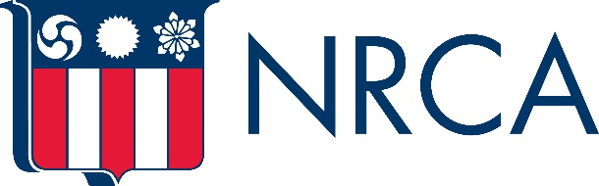
Insert Official Company Logo

FOR IMMEDIATE RELEASE CONTACT: (Contact Name)
Date: (Insert Date) (Phone #)
(email)

(Insert Roofing Company Name) to Recognize the Importance of Roofs, Roofing Industry During National Roofing Week, June 4-10

(Dateline City, State) – To raise awareness of the significance of roofs to every home and business, stress the value of professional roofing contractors, and promote the good deeds of the industry, (Insert Roofing Company Name) will recognize National Roofing Week taking place June 4-10.

Organized by the National Roofing Contractors Association, National Roofing Week is a reminder that the roof is one of the most important components of every structure. It is the first line of defense against natural elements, such as rain, snow or wind, yet it is often taken for granted until it falls into disrepair.

National Roofing Week enables roofing professionals to engage in their communities and inform the public about the essential role roofs and professional roofing contractors play in every community, as well as the importance of making informed decisions about maintaining or replacing any roof system.

During National Roofing Week, (Insert Roofing Company Name) will (Insert activities planned for National Roofing Week).

“Quote from company official”

Additional information about National Roofing Week can be found at www.nrca.net/nationalroofingweek.

###

Insert company boilerplate, or a paragraph briefly describing your company and its purpose. For reference, NRCA’s boilerplate is below.

Since 1886, the National Roofing Contractors Association has been the home for generations of entrepreneurial craftsmen and enterprises who shelter and protect America’s families and businesses and each other. Our vision is the recognition of our members as professionals and to unite the industry to that purpose. NRCA is one of the construction industry’s most respected trade associations and the voice of roofing professionals and leading authority in the roofing industry for information, education, technology and advocacy. It represents all segments of the roofing industry, including contractors; manufacturers; distributors; architects; consultants; engineers; building owners; and city, state and government agencies. For information about NRCA and its services and offerings, visit nrca.net.

